**PL/SQL ASSIGNMENT R12 GENERAL LEDGER**

**EMPLOYEE NAME: Malik Basha S**

**EMPLOYEE ID: 1439**

**ASSIGNMENT - Title: Customer and Credit Management Information Query**

**Objective:**

Retrieve comprehensive information about customers and their credit management details.

**GIVEN QUERY:**

SELECT DISTINCT hzp.party_name,  
 hzp.orig_system_reference party_osr,  
 hzp.party_number,  
 hzp.party_type,  
 hzp.duns_number,  
 hzp.tax_reference,  
 hzp.category_code,  
 hzc.orig_system_reference cust_osr,  
 hzc.account_number,  
 hzc.account_name,  
 hou.NAME ou_name,  
 (SELECT a.NAME  
 FROM ar.hz_cust_profile_classes a  
 WHERE a.profile_class_id = hzcp.profile_class_id  
 ) profile_class_name,  
 (SELECT a.NAME  
 FROM ar.ar_collectors a  
 WHERE a.collector_id = hzcp.collector_id  
 ) collector_name,  
 (SELECT a.NAME  
 FROM ar.ar_statement_cycles a  
 WHERE statement_cycle_id = hzcp.statement_cycle_id  
 ) statement_cycle_name,  
 (SELECT a.NAME   
 FROM apps.ra_terms a   
 WHERE a.term_id = hzcp.standard_terms) payment_term_name,  
 (SELECT a.NAME  
 FROM ar.ra_grouping_rules a  
 WHERE a.grouping_rule_id = hzcp.grouping_rule_id) grouping_rules_name,  
 (SELECT a.orig_system_reference  
 FROM hz_cust_site_uses_all a  
 WHERE a.site_use_id = hzcp.site_use_id) profile_site_use_osr,  
 hzcp.credit_checking,  
 hzcp.tolerance,  
 hzcp.credit_hold,  
 hzcp.credit_balance_statements,  
 hzcp.send_statements,  
 hzcp.jgzz_attribute1 enable_late_charges,  
 hzcp.interest_charges,  
 hzcp.jgzz_attribute2 late_charge_calculation_trx,  
 hzcp.jgzz_attribute5 hold_charged_invoices_flag,  
 hzcp.dunning_letters,  
 hzcp.discount_terms,  
 hzcp.interest_period_days,  
 hzcp.payment_grace_days,  
 hzcp.discount_grace_days,  
 hzcp.auto_rec_incl_disputed_flag,  
 hzcp.attribute_category cust_prof_dff_category,   
 hzcp.attribute2 cust_prof_dff_attr2,  
 hzcpm.currency_code,  
 hzcpm.trx_credit_limit,  
 hzcpm.overall_credit_limit,  
 hzcpm.min_dunning_amount,  
 hzcpm.min_dunning_invoice_amount,  
 hzcpm.max_interest_charge,  
 hzcpm.min_statement_amount,  
 hzcpm.auto_rec_min_receipt_amount,  
 hzcpm.interest_rate,  
 hzcpm.min_fc_balance_amount,  
 hzcpm.min_fc_invoice_amount,  
 (SELECT a.orig_system_reference  
 FROM hz_cust_site_uses_all a  
 WHERE a.site_use_id = hzcpm.site_use_id  
 ) profile_amt_site_use_osr  
 FROM ar.hz_parties hzp,  
 ar.hz_cust_accounts hzc,  
 ar.hz_cust_acct_sites_All has,  
 ar.hz_customer_profiles hzcp,  
 ar.hz_cust_profile_amts hzcpm,  
 apps.hr_operating_units hou  
 WHERE hzp.party_id = hzc.party_id  
 AND hzc.cust_account_id = hzcp.cust_account_id  
 and hzcp.cust_account_profile_id = hzcpm.cust_account_profile_id(+)  
 AND has.cust_account_id = hzc.cust_Account_id  
 AND HAS.ORG_ID = HOU.ORGANIZATION_ID  
 AND hou.organization_id = 105 -- Operating unit id  
 -- Customer is active and created after cut off date  
 AND ((trunc(hzc.creation_date) >'01-MAY-2012' and hzc.status = 'A')  
 -- AR invoices created after cut off date  
 or exists  
 (SELECT 1  
 FROM ar.ra_customer_trx_all t  
 WHERE trunc(t.trx_date)>'01-MAY-2012'  
 and t.bill_to_customer_id = hzc.cust_account_id  
 and t.org_id = hzc.org_id  
 and hzc.status = 'A')  
 -- AR invoice Payments are in open status   
 or exists  
 (SELECT 1  
 FROM ar.ar_payment_schedules_all apsa  
 WHERE apsa.CLASS IN ('INV', 'CM', 'DM','PMT')  
 AND apsa.status = 'OP'  
 AND apsa.org_id = hzc.org_id  
 AND apsa.customer_id = hzc.cust_account_id  
 AND to_number(apsa.acctd_amount_due_remaining) <>  
 to_number('0')  
 GROUP BY apsa.customer_id  
 having sum(nvl(apsa.acctd_amount_due_remaining,0))<>0));

**OUTPUT FOR THE GIVEN QUERY:**

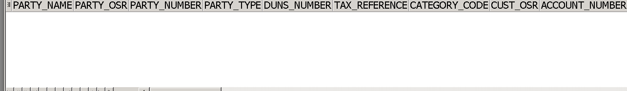

**ERROR FINDING: -**

•  **Organization id mentioned in these table is not valid, so I replace another organization id.**

• **SOME ALIAS NAMES WERE NOT GIVEN CORRECTLY.** **error find it allies name can't mention**

**Reference:-**

**All are run Properly with Data**

select * from apps.HZ_PARTIES;

This query is used to fetch the customer information of the hz_parties table.

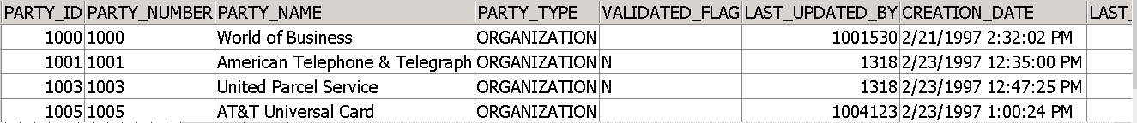

select * from apps.HZ_CUST_ACCOUNTS;

This query is used to fetch the customer account information of the hz_cust_accounts table



select * from apps.HZ_CUST_ACCT_SITES_ALL;

This query is used to fetch the customer site details like location, address etc of hz_cust_acct_site_all table

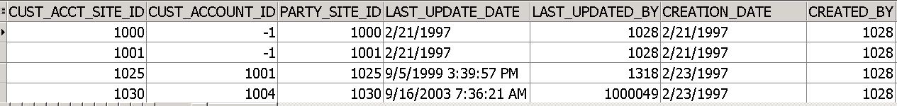

select * from apps.HZ_CUSTOMER_PROFILES;

This query retrieves all columns (**\***) from the **HZ_CUSTOMER_PROFILES** table in the **APPS** schema. It is used to fetch information related to customer profiles.

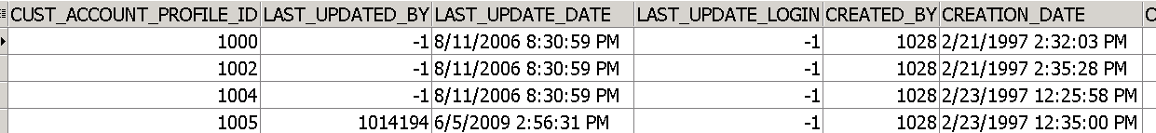

select * from apps.HZ_CUST_PROFILE_AMTS;

This query retrieves all columns (**\***) from the **HZ_CUST_PROFILE_AMTS** table in the **APPS** schema. It is used to fetch customer profile amounts, indicating financial information associated with customer profiles.

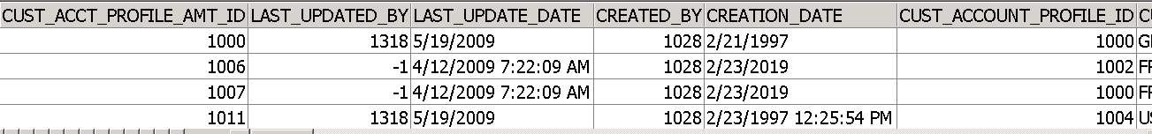

select * from apps.HZ_CUST_SITE_USES_ALL;

This query retrieves all columns (**\***) from the **HZ_CUST_SITE_USES_ALL** table in the **APPS** schema. It is used to fetch information about customer site uses, including details related to site usage.

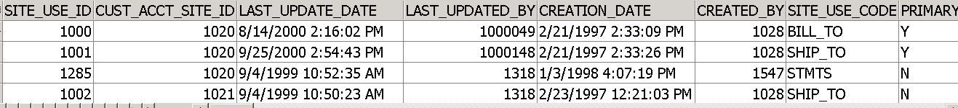

select * from apps.RA_GROUPING_RULES;

This query retrieves all columns (**\***) from the **RA_GROUPING_RULES** table in the **APPS** schema. It is used to fetch information about grouping rules, which are typically associated with revenue recognition.

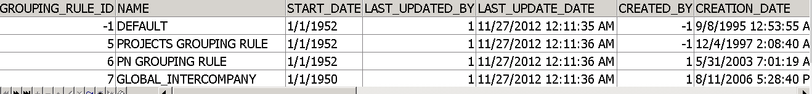

select * from apps.AR_STATEMENT_CYCLES;

This query retrieves all columns (**\***) from the **AR_STATEMENT_CYCLES** table in the **APPS** schema. It is used to fetch information related to accounts receivable statement cycles.

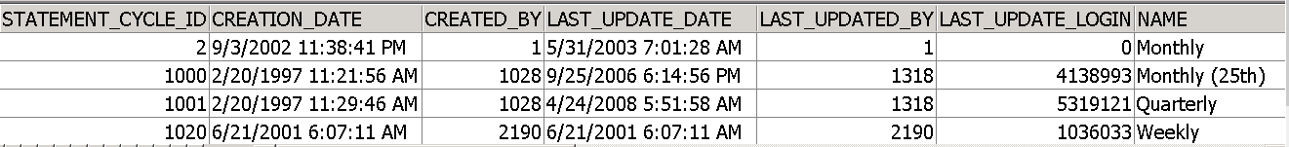

select * from apps.RA_TERMS;

This query retrieves all columns (**\***) from the **RA_TERMS** table in the **APPS** schema. It is used to fetch information about terms, often related to revenue recognition.

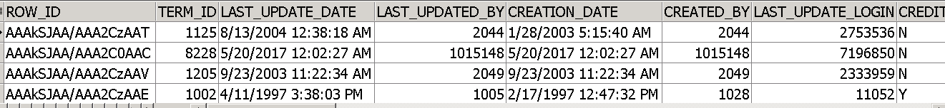

select * from apps.AR_COLLECTORS;

This query retrieves all columns (**\***) from the **AR_COLLECTORS** table in the **APPS** schema. It is used to fetch information about collectors, who are responsible for managing and collecting outstanding accounts receivable.

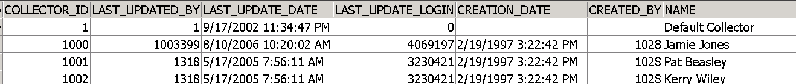

select * from apps.HZ_CUST_PROFILE_CLASSES;

This query retrieves all columns (**\***) from the **HZ_CUST_PROFILE_CLASSES** table in the **APPS** schema. It is used to fetch information about customer profile classes, which are typically used to categorize or classify customer profiles.

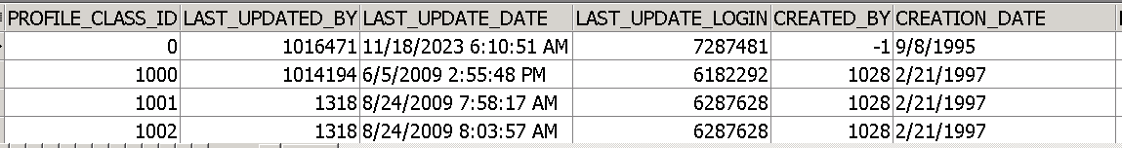

**CORRECTED QUERY:**

SELECT DISTINCT hzp.party_name,

hzp.orig_system_reference party_osr,

hzp.party_number,

hzp.party_type,

hzp.duns_number,

hzp.tax_reference,

hzp.category_code,

hzc.orig_system_reference cust_osr,

hzc.account_number,

hzc.account_name,

hou.NAME ou_name,

(

SELECT a.NAME

FROM ar.hz_cust_profile_classes a

WHERE a.profile_class_id = hzcp.profile_class_id

) profile_class_name,

(

SELECT a.NAME FROM ar.ar_collectors a

WHERE a.collector_id = hzcp.collector_id

) collector_name,

(

SELECT a.NAME

FROM ar.ar_statement_cycles a

WHERE **a.**statement_cycle_id = hzcp.statement_cycle_id --error find it allies name cant mention a.

--is not mentiontion before statement

) statement_cycle_name,

(

SELECT a.NAME

FROM apps.ra_terms a

WHERE a.term_id = hzcp.standard_terms

) payment_term_name,

(

SELECT a.NAME

FROM ar.ra_grouping_rules a

WHERE a.grouping_rule_id = hzcp.grouping_rule_id

) grouping_rules_name,

(

SELECT a.orig_system_reference

FROM **ar.**hz_cust_site_uses_all a --error find the ar schema can't mention it is ar. before from

WHERE a.site_use_id = hzcp.site_use_id

) profile_site_use_osr,

hzcp.credit_checking,

hzcp.tolerance,

hzcp.credit_hold,

hzcp.credit_balance_statements,

hzcp.send_statements, hzcp.jgzz_attribute1 enable_late_charges,

hzcp.interest_charges,

hzcp.jgzz_attribute2 late_charge_calculation_trx,

hzcp.jgzz_attribute5 hold_charged_invoices_flag,

hzcp.dunning_letters,

hzcp.discount_terms,

hzcp.interest_period_days,

hzcp.payment_grace_days,

hzcp.discount_grace_days,

hzcp.auto_rec_incl_disputed_flag,

hzcp.attribute_category cust_prof_dff_category,

hzcp.attribute2 cust_prof_dff_attr2,

hzcpm.currency_code,

hzcpm.trx_credit_limit,

hzcpm.overall_credit_limit,

hzcpm.min_dunning_amount,

hzcpm.min_dunning_invoice_amount,

hzcpm.max_interest_charge,

hzcpm.min_statement_amount,

hzcpm.auto_rec_min_receipt_amount,

hzcpm.interest_rate,

hzcpm.min_fc_balance_amount,

hzcpm.min_fc_invoice_amount,

(

SELECT a.orig_system_reference

FROM ar.hz_cust_site_uses_all a -- same schema error

WHERE a.site_use_id = hzcpm.site_use_id

) profile_amt_site_use_osr

FROM ar.hz_parties hzp,

ar.hz_cust_accounts hzc,

ar.hz_cust_acct_sites_All has,

ar.hz_customer_profiles hzcp,

ar.hz_cust_profile_amts hzcpm,

apps.hr_operating_units hou--no data

WHERE

hzp.party_id = hzc.party_id

AND hzc.cust_account_id = hzcp.cust_account_id

and hzcp.cust_account_profile_id = hzcpm.cust_account_profile_id(+)

AND has.cust_account_id = hzc.cust_Account_id

AND HAS.ORG_ID = HOU.ORGANIZATION_ID

AND hou.organization_id = 889-- Operating unit id company -**-105 organization id not here**

-- Customer is active and created after cut off date

AND (trunc(hzc.creation_date) >'01-MAY-2000' and hzc.status = 'A'); **--2011 date here**

**Explanation:**

This SQL query retrieves information related to customer and credit management from various tables.

* Columns selected include details about parties, customer accounts, operating units, and various attributes related to credit management.
* Subqueries are used to fetch additional information, such as collector names and profile class names.
* The query includes join conditions to link the necessary tables, and it filters data based on creation date, customer status, and operating unit.

**OUTPUT FOR THE CORRECTED QUERY:**

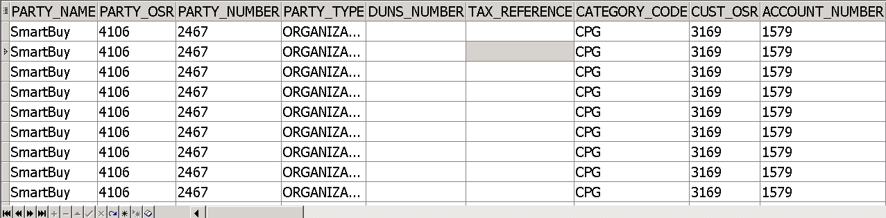

**CODE EXPLANATION:**

#### SELECT Clause:

* **Columns Selected:**
  + **hzp.party_name**
  + **hzp.orig_system_reference** AS **party_osr**
  + **hzp.party_number**
  + **hzp.party_type**
  + **hzp.duns_number**
  + **hzp.tax_reference**
  + **hzp.category_code**
  + **hzc.orig_system_reference** AS **cust_osr**
  + **hzc.account_number**
  + **hzc.account_name**
  + **hou.NAME** AS **ou_name**
  + ...

#### FROM Clause:

* **Specifies the tables used in the query:**
  + **ar.hz_parties hzp**
  + **ar.hz_cust_accounts hzc**
  + **ar.hz_cust_acct_sites_All has**
  + **ar.hz_customer_profiles hzcp**
  + **ar.hz_cust_profile_amts hzcpm**
  + **apps.hr_operating_units hou**

#### WHERE Clause:

* **Conditions to filter the rows:**
  + Join conditions (**hzp.party_id = hzc.party_id**, etc.)
  + Date condition (**trunc(hzc.creation_date) > '01-MAY-2000' AND hzc.status = 'A'**)
  + Operating unit condition (**hou.organization_id = 889**)

#### **Conclusion:**

* This SQL query is designed to extract comprehensive customer and credit management information. It involves multiple tables and subqueries to retrieve additional details. The conditions in the **WHERE** clause filter the data based on specific criteria.